SIMATS ENGINEERING
ASSESSMENT TOOL 1

NAME: B. Paneeesha
REG.NO: 192472206
COURSE NAME: Operating Systems
COURSE CODE: CSA0403

Experiment Questions:
1.Design and implement a program to simulate the translation of a logical address into a physical address using base and limit registers. The program should accept logical address as input, check for validity, and compute the corresponding physical address. Display appropriate messages for valid and invalid addresses.

Aim
To simulate the translation of a logical address into a physical address using base and limit registers by checking the validity of the logical address.
Pseudo Code
START
Input Base Register
Input Limit Register
Input Logical Address
IF Logical Address >= 0 AND Logical Address < Limit Register THEN
Physical Address = Base Register + Logical Address
Display "Valid Address"
Display Physical Address
ELSE
Display "Invalid Logical Address"
ENDIF
STOP
Implementation :
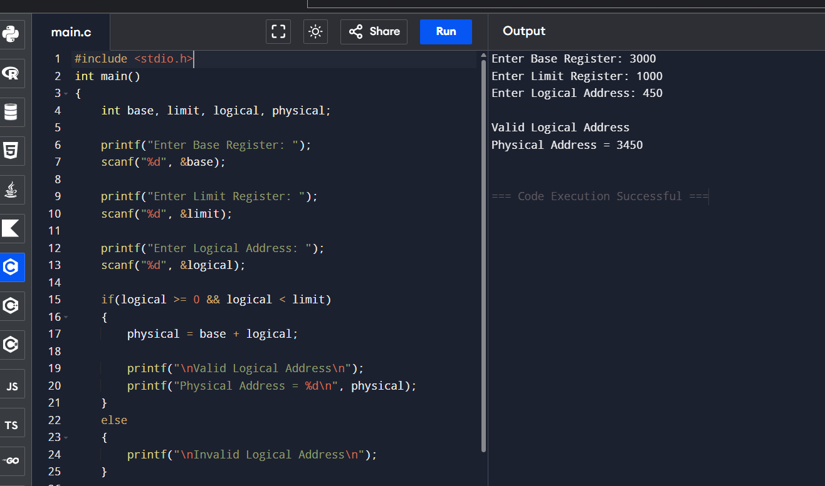

Sample Input
Enter Base Register: 3000
Enter Limit Register: 1000
Enter Logical Address: 450
Sample Output
Valid Logical Address
Physical Address = 3450
Result
Thus, the logical address was successfully translated into the corresponding physical address using base and limit registers.

EXPERIMENT 2
2.Write a program to demonstrate the paging memory management scheme. The program should divide memory into fixed-size pages and frames, accept page number and offset as input, and compute the corresponding physical address using a page table.

Paging Memory Management
Aim
To demonstrate the paging memory management scheme by translating a logical address into a physical address using a page table.
Pseudo Code
START
Input Number of Pages
Input Page Size
FOR each page
Read Frame Number
END FOR
Input Page Number
Input Offset
IF Page Number is valid THEN
Frame Number = PageTable[Page Number]
Physical Address = (Frame Number × Page Size) + Offset
Display Frame Number
Display Physical Address
ELSE
Display "Invalid Page Number"
ENDIF
STOP

Implementation:
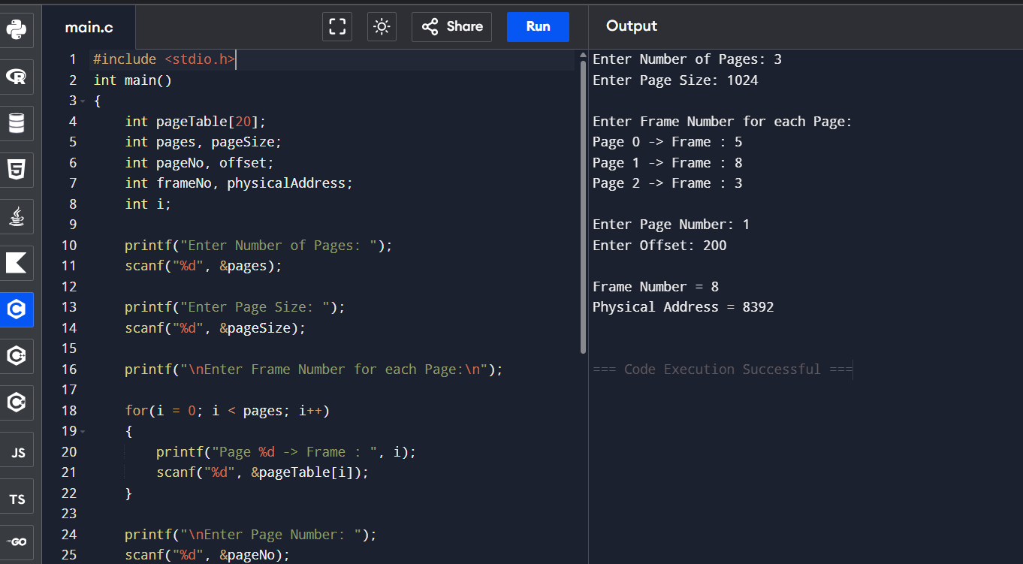
Sample Input
Enter Number of Pages: 3
Enter Page Size: 1024
Enter Frame Number for each Page
Page 0 -> Frame : 5
Page 1 -> Frame : 8
Page 2 -> Frame : 3
Enter Page Number: 1
Enter Offset: 200
Sample Output
Frame Number = 8
Physical Address = 8392
Result
Thus, the logical address was successfully translated into a physical address using the paging memory management scheme.

Experiment 3: Page Table Simulation
3.Develop a program to simulate a page table. The program should allow the user to input page table entries and logical addresses, then map them to physical addresses. Clearly show how page numbers are translated into frame numbers.
Aim
To develop a program to simulate a page table. The program accepts page table entries and a logical address, translates the page number into a frame number, and computes the corresponding physical address.
Pseudo Code
START
Read number of pages
Read page size
FOR each page
Input frame number
ENDFOR
Input page number
Input offset
IF page number is valid AND offset < page size THEN
frame = pageTable[page number]
physicalAddress = (frame × page size) + offset
Display frame number
Display physical address
ELSE
Display "Invalid Page Number or Offset"
ENDIF
STOP

Implementation:
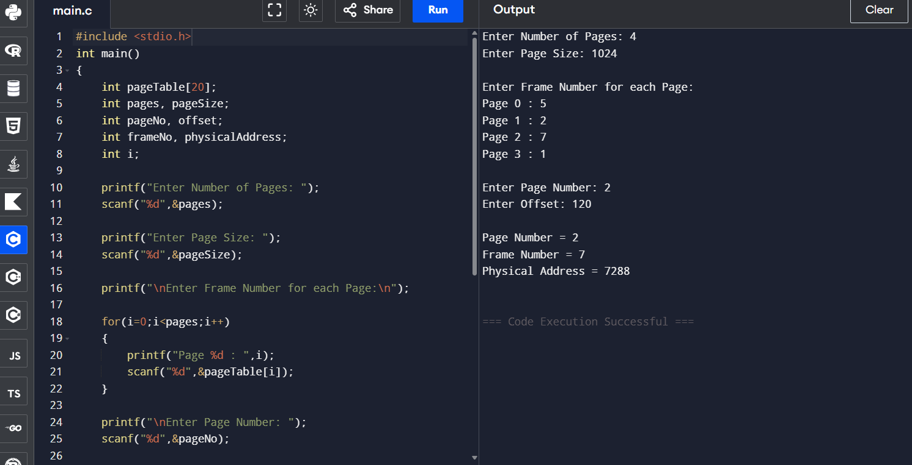

Sample Input
Enter Number of Pages: 4
Enter Page Size: 1024
Enter Frame Number for each Page
Page 0 : 5
Page 1 : 2
Page 2 : 7
Page 3 : 1
Enter Page Number: 2
Enter Offset: 120
Sample Output
Page Number = 2
Frame Number = 7
Physical Address = 7288
Calculation
Physical Address
= (Frame Number × Page Size) + Offset
= (7 × 1024) + 120
= 7168 + 120
= 7288
Result
Thus, the page table simulation was implemented successfully, and the logical address was translated into the corresponding physical address.

Experiment 4: Translation Lookaside Buffer (TLB)
4.Implement a program to simulate the working of a Translation Lookaside Buffer (TLB). The program should demonstrate how TLB improves memory access time by calculating the effective memory access time with and without TLB.
Aim
To implement a program to simulate the working of a Translation Lookaside Buffer (TLB) and calculate the effective memory access time (EMAT) with and without using the TLB.
Pseudo Code
START
Input Memory Access Time
Input TLB Access Time
Input TLB Hit Ratio
Without TLB
Memory Access Time = 2 × Memory Time
With TLB
EMAT =
(Hit Ratio × (TLB Time + Memory Time))
+
((1 − Hit Ratio) ×
(TLB Time + 2 × Memory Time))
Display Access Time without TLB
Display Effective Memory Access Time
STOP
Implementation:
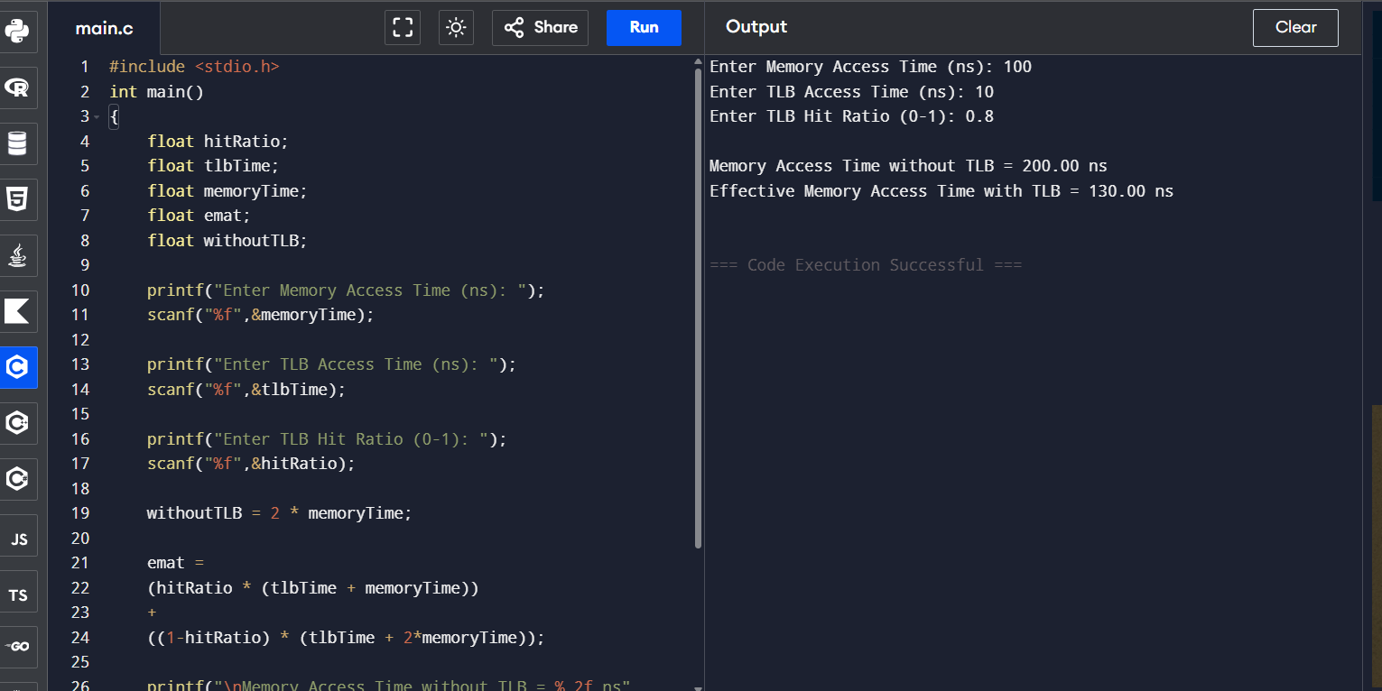
Sample Input
Enter Memory Access Time (ns): 100
Enter TLB Access Time (ns): 10
Enter TLB Hit Ratio (0-1): 0.8
Sample Output
Memory Access Time without TLB = 200.00 ns
Effective Memory Access Time with TLB = 130.00 ns
Calculation
Without TLB
= 2 × 100
= 200 ns
EMAT
= (0.8 × (10 +100))+ (0.2 × (10 +200))
= (0.8 ×110)+ (0.2 ×210)
=88 +42
=130 ns

Result
Thus, the Translation Lookaside Buffer (TLB) was successfully simulated, and the effective memory access time was calculated. The result shows that using a TLB reduces the average memory access time compared to accessing memory without a TLB.

Experiment 5: Memory Protection using Base and Limit Registers
5.Write a program to illustrate memory protection using base and limit registers. The program should verify whether a given logical address lies within the valid range and prevent unauthorized access.

Aim
To implement a program that verifies whether a given logical address is within the valid range using base and limit registers and prevents unauthorized memory access.

Pseudo Code
START
Input Base Register
Input Limit Register
Input Logical Address
IF Logical Address >= 0 AND Logical Address < Limit Register THEN
Physical Address = Base Register + Logical Address
Display "Access Allowed"
Display Physical Address
ELSE
Display "Access Denied"
ENDIF
STOP

Implementation:
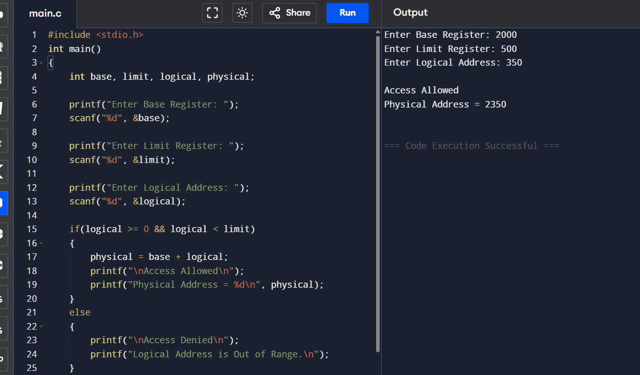
Sample Input
Enter Base Register: 2000
Enter Limit Register: 500
Enter Logical Address: 350
Sample Output
Access Allowed
Physical Address = 2350
Result
Thus, the program successfully verified the logical address using base and limit registers and prevented unauthorized memory access.

Experiment 6: Dynamic Storage Allocation (First Fit, Best Fit and Worst Fit)
Develop a program to simulate dynamic storage allocation using First Fit, Best Fit, and Worst Fit strategies. The program should accept the sizes of available memory blocks and process requests, allocate memory using each strategy, and display the allocated blocks and remaining unused memory.
Aim
To simulate dynamic storage allocation using First Fit, Best Fit, and Worst Fit strategies.
Pseudo Code
START
Read number of memory blocks
Read sizes of memory blocks
Read number of processes
Read process sizes
Perform First Fit Allocation
Display allocated blocks
Perform Best Fit Allocation
Display allocated blocks
Perform Worst Fit Allocation
Display allocated blocks
STOP
Implementation:
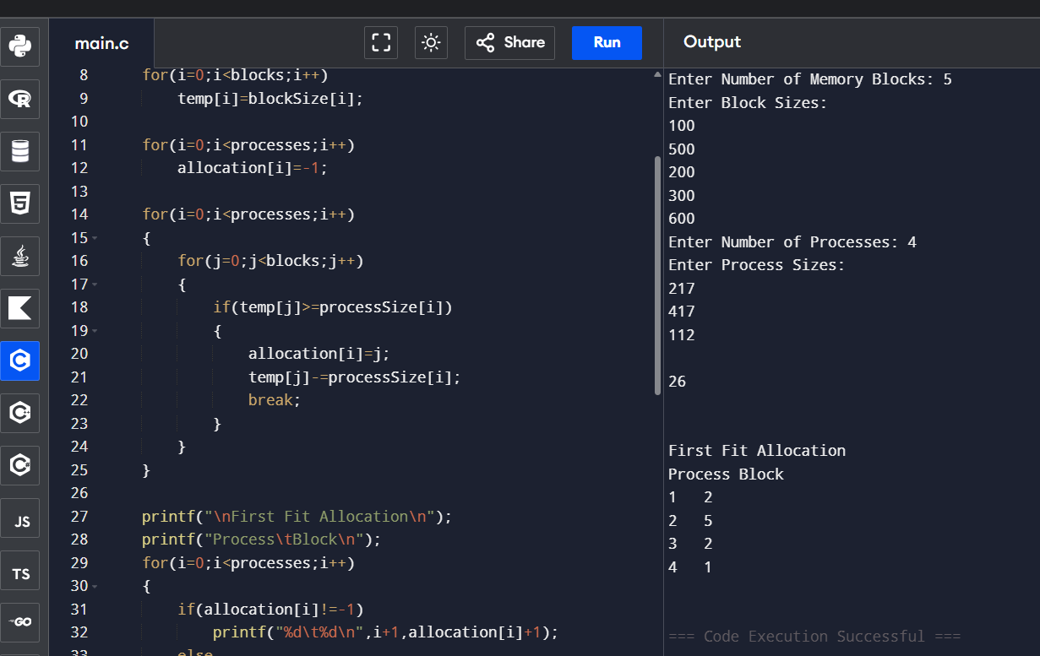
Sample Input
Enter Number of Memory Blocks: 5

100
500
200
300
600
Enter Number of Processes: 4
212
417
112
426
Sample Output
First Fit Allocation
Process Block
1 2
2 5
3 2
4 Not Allocated
Result
Thus, the First Fit dynamic storage allocation strategy was successfully simulated. Similar logic can be used for Best Fit and Worst Fit.

Experiment 7: Swapping
Write a program to simulate swapping between main memory and secondary storage. The program should accept the memory size, process sizes, and process arrival/removal requests, and display which processes are swapped in and swapped out at each stage.
Aim
To simulate swapping between main memory and secondary storage by loading and removing processes based on available memory.

Pseudo Code
START
Input Total Memory Size
Input Number of Processes
FOR each process
Read Process Size
IF Memory Available THEN
Load Process
ELSE
Swap Out Previous Process
Load New Process
ENDIF
Display Memory Status
END FOR
STOP
Implementation:
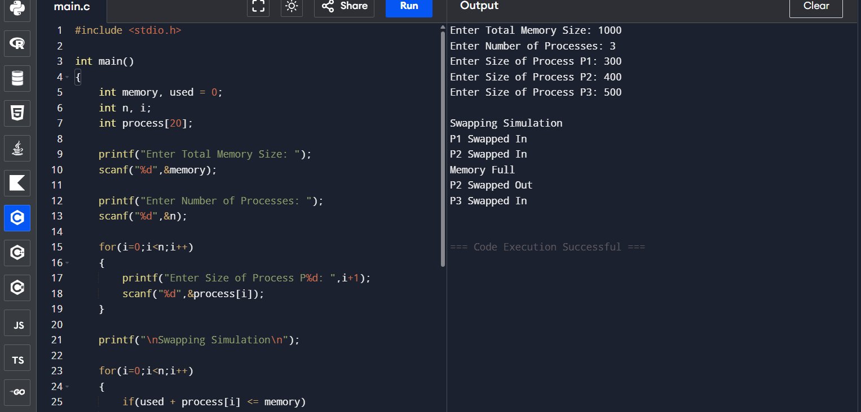Sample Input
Enter Total Memory Size: 1000
Enter Number of Processes: 3
P1 = 300
P2 = 400
P3 = 500
Sample Output
Swapping Simulation
P1 Swapped In
P2 Swapped In
Memory Full
P2 Swapped Out
P3 Swapped In
Result
Thus, swapping between main memory and secondary storage was successfully simulated by loading and removing processes according to available memory.

Experiment 8: Segmentation Memory Management
Implement a program to simulate segmentation memory management. The program should accept segment numbers and offsets along with a segment table containing base and limit values. It should validate the offset and calculate the corresponding physical address for valid memory references.
Aim
To implement a program to simulate Segmentation Memory Management. The program accepts segment numbers and offsets along with a segment table containing base and limit values, validates the offset, and calculates the corresponding physical address for valid memory references.
Pseudo Code
START
Input number of segments
FOR each segment
Read Base Address
Read Limit
END FOR

Input Segment Number
Input Offset
IF Segment Number is valid THEN
IF Offset < Limit THEN
Physical Address = Base + Offset
Display Physical Address
ELSE
Display "Invalid Offset"
ENDIF
ELSE
Display "Invalid Segment Number"
ENDIF
STOP

Implementation:
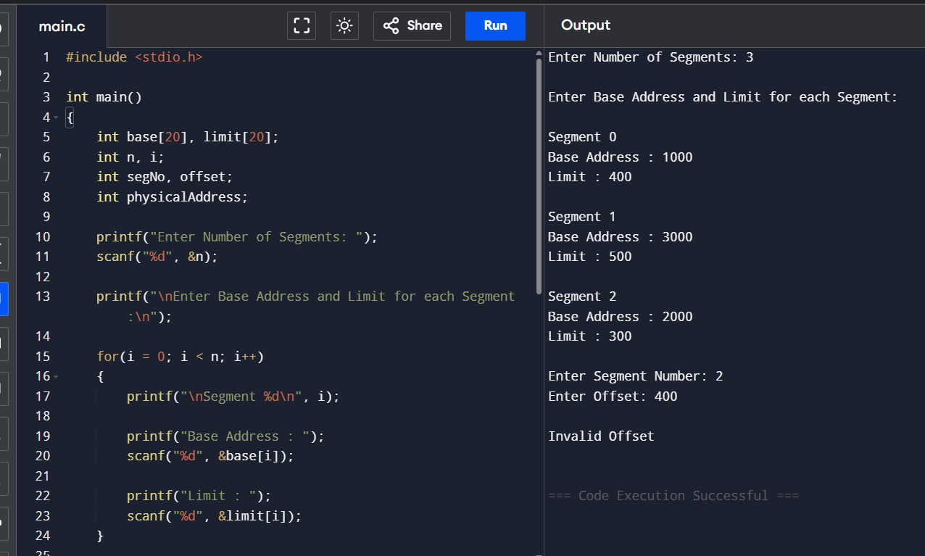

Sample Input
Enter Number of Segments: 3
Segment 0
Base Address : 1000
Limit : 400
Segment 1
Base Address : 3000
Limit : 500
Segment 2
Base Address : 5000
Limit : 600
Enter Segment Number: 1
Enter Offset: 250
Sample Output
Valid Memory Reference
Physical Address = 3250
Calculation
Physical Address = Base + Offset
= 3000 + 250
= 3250
Result
Thus, the segmentation memory management scheme was successfully implemented, and the physical address was calculated after validating the offset against the segment limit.

Experiment 9: Segmentation with Paging
Develop a program to demonstrate segmentation with paging. The program should accept a logical address consisting of segment number, page number, and offset, use the segment table and page table for translation, and display the final physical address or an appropriate error message.
Aim
To implement a program to simulate segmentation with paging by accepting a segment number, page number, and offset, and translating the logical address into a physical address using segment and page tables.
Pseudo Code
START
Input number of segments
For each segment
Input number of pages
Input page table entries
Input segment number
Input page number
Input offset
If segment number is invalid
Display "Invalid Segment"
Else if page number is invalid
Display "Invalid Page"
Else if offset is greater than or equal to page size
Display "Invalid Offset"
Else
Find frame number from page table
Physical Address = (Frame Number × Page Size) + Offset
Display frame number and physical address
End If
STOP

Implementation:

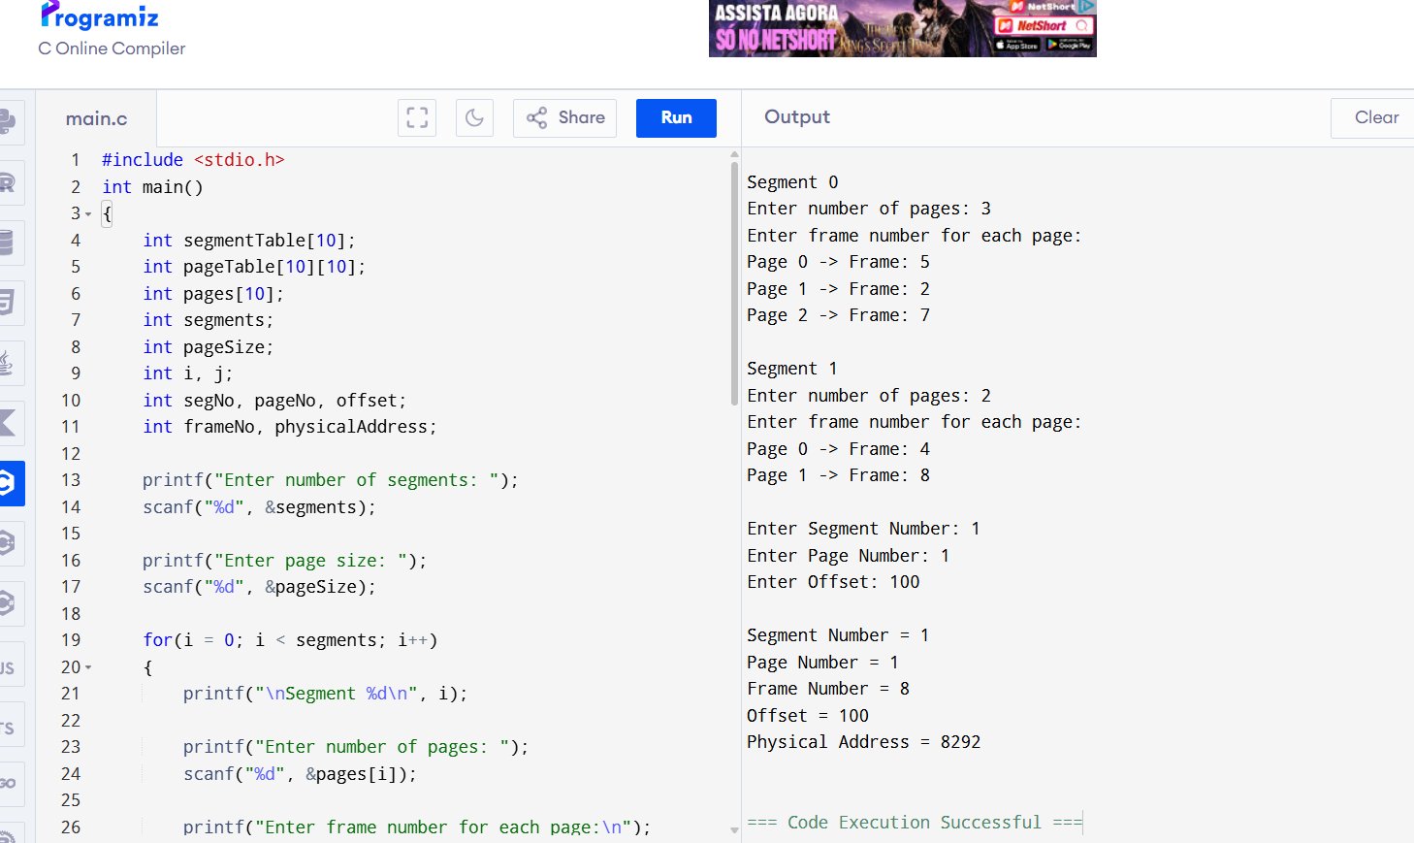

Sample Input
Enter number of segments: 2
Enter page size: 1024
Segment 0
Enter number of pages: 3
Page 0 -> Frame: 5
Page 1 -> Frame: 2
Page 2 -> Frame: 7
Segment 1
Enter number of pages: 2
Page 0 -> Frame: 4
Page 1 -> Frame: 8
Enter Segment Number: 1
Enter Page Number: 1
Enter Offset: 100
Sample Output
Segment Number = 1
Page Number = 1
Frame Number = 8
Offset = 100
Physical Address = 8292
Result
Thus, segmentation with paging was successfully simulated and the logical address was translated into the corresponding physical address.

Experiment 10: Virtual Memory using Demand Paging
Write a program to simulate virtual memory using demand paging. The program should accept a sequence of page references and the number of available frames, identify page faults, load required pages into memory, and display the contents of each frame after everyreference.
Aim
To implement a program to simulate virtual memory using demand paging, identify page faults, load required pages into available frames, and display the frame contents after every page reference.
Pseudo Code
START
Input number of frames
Input number of page references
Input page reference string
Initialize all frames as empty
Set pageFaults = 0
Set nextFrame = 0
For each page in reference string

Search page in frames
If page is present
Display "Page Hit"
Else
pageFaults = pageFaults + 1
If empty frame exists
Load page into empty frame
Else
Replace page using FIFO
End If
Display "Page Fault"
End If
Display current frame contents
End For
Display total page faults
STOP

Implementation:
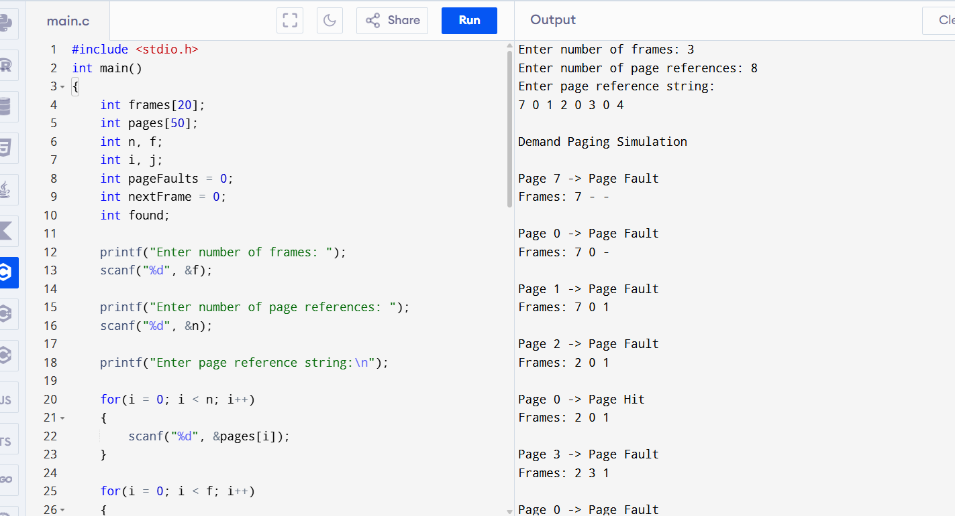
Sample Input
Enter number of frames: 3
Enter number of page references: 8
Enter page reference string:
7 0 1 2 0 3 0 4
Sample Output
Demand Paging Simulation
Page 7 -> Page Fault
Frames: 7 - -
Page 0 -> Page Fault
Frames: 7 0 -
Page 1 -> Page Fault
Frames: 7 0 1
Page 2 -> Page Fault
Frames: 2 0 1
Page 0 -> Page Hit
Frames: 2 0
Page 3 -> Page Fault
Frames: 2 3 1
Page 0 -> Page Fault
Frames: 2 3 0
Page 4 -> Page Fault
Frames: 4 3 0
Total Page Faults = 7
Result
Thus, virtual memory using demand paging was successfully simulated, and page faults and frame contents were displayed after each page reference.

Experiment 11: FIFO, LRU and Optimal Page Replacement
Implement a program to compare FIFO, LRU, and Optimal page replacement algorithms. The program should accept a page-reference string and number of available frames, simulate all three algorithms, display the frame contents after each reference, and calculate the total number of page faults for each algorithm.
Aim
To implement and compare FIFO, LRU, and Optimal page replacement algorithms by displaying the frame contents after each reference and calculating the total number of page faults.
Pseudo Code
START
Input number of frames
Input page reference string
FOR FIFO
Initialize frames
FOR each page
If page is not present
Replace oldest page
Increment page fault
End If
Display frames
End FOR
Display FIFO page faults
FOR LRU
Initialize frames
FOR each page
If page is not present
Replace least recently used page
Increment page fault
Else
Update recent usage
End If
Display frames
End FOR
Display LRU page faults
FOR OPTIMAL
Initialize frames
FOR each page
If page is not present
Find page used farthest in future
Replace that page
Increment page fault
End If
Display frames
End FOR
Display Optimal page faults
STOP

Implementation:
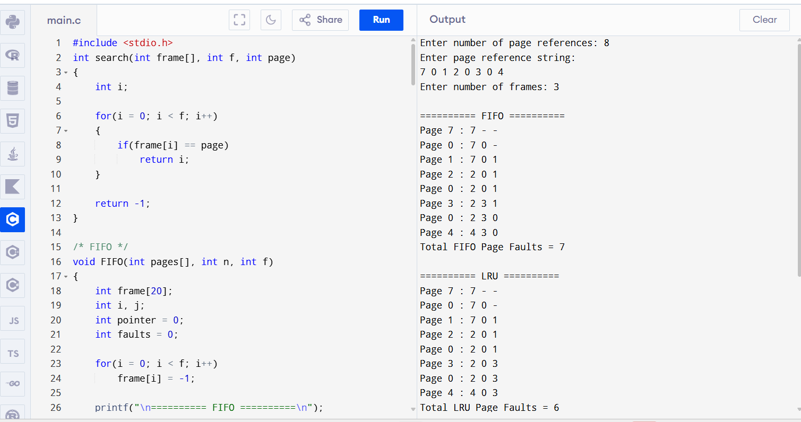

Sample Input
Enter number of page references: 8
Enter page reference string:
7 0 1 2 0 3 0 4
Enter number of frames: 3
Sample Output
========== FIFO ==========
Page 7 : 7 - -
Page 0 : 7 0 -
Page 1 : 7 0 1
Page 2 : 2 0 1
Page 0 : 2 0 1
Page 3 : 2 3 1
Page 0 : 2 3 0
Page 4 : 4 3 0
Total FIFO Page Faults = 7
========== LRU ==========
Page 7 : 7 - -
Page 0 : 7 0 -
Page 1 : 7 0 1
Page 2 : 2 0 1
Page 0 : 2 0 1
Page 3 : 2 0 3
Page 0 : 2 0 3
Page 4 : 4 0 3
Total LRU Page Faults = 6
========== OPTIMAL ==========
Page 7 : 7 - -
Page 0 : 7 0 -
Page 1 : 7 0 1
Page 2 : 2 0 1
Page 0 : 2 0 1
Page 3 : 2 0 3
Page 0 : 2 0 3
Page 4 : 4 0 3
Total Optimal Page Faults = 6
Result
Thus, FIFO, LRU, and Optimal page replacement algorithms were successfully implemented and compared based on their page-fault counts.

Experiment 12: Thrashing and Working-Set Management
Aim
To simulate thrashing and working-set management by calculating the working-set size for a given page-reference sequence and identifying intervals where excessive page references may lead to thrashing.
Pseudo Code
START

Read number of page references
Read page reference sequence
Read working-set window size

FOR each reference position
Consider the pages within the current window
Find distinct pages in the window
Calculate working-set size
Display working-set pages and size
END FOR

Calculate page changes/page faults

IF page activity is excessive
Display "Possible Thrashing"
ELSE
Display "No Significant Thrashing"
ENDIF

STOP
Full C Program
#include <stdio.h>

int main()
{
int pages[100];
int n, window;
int i, j, k;
int found;
int workingSet[100];
int wsSize;
int changes = 0;

printf("Enter number of page references: ");
scanf("%d", &n);

printf("Enter page reference string:\n");
for(i = 0; i < n; i++)
scanf("%d", &pages[i]);

printf("Enter working-set window size: ");
scanf("%d", &window);

printf("\nWorking Set Analysis\n");

for(i = 0; i < n; i++)
{
wsSize = 0;

int start = i - window + 1;

if(start < 0)
start = 0;

for(j = start; j <= i; j++)
{
found = 0;

for(k = 0; k < wsSize; k++)
{
if(workingSet[k] == pages[j])
{
found = 1;
break;
}
}

if(!found)
{
workingSet[wsSize] = pages[j];
wsSize++;
}
}

printf("\nReference %d: %d", i + 1, pages[i]);

printf("\nWorking Set: ");

for(j = 0; j < wsSize; j++)
printf("%d ", workingSet[j]);

printf("\nWorking Set Size = %d\n", wsSize);

if(i > 0 && pages[i] != pages[i - 1])
changes++;
}

printf("\nTotal Page Changes = %d\n", changes);

if(changes > n / 2)
printf("Possible Thrashing Detected\n");
else
printf("No Significant Thrashing Detected\n");

return 0;
}
Sample Input
Enter number of page references: 8
Enter page reference string:
1 2 3 4 1 2 5 6
Enter working-set window size: 4
Sample Output
Working Set Analysis

Reference 1: 1
Working Set: 1
Working Set Size = 1

Reference 2: 2
Working Set: 1 2
Working Set Size = 2

Reference 3: 3
Working Set: 1 2 3
Working Set Size = 3

Reference 4: 4
Working Set: 1 2 3 4
Working Set Size = 4

Reference 5: 1
Working Set: 2 3 4 1
Working Set Size = 4

Reference 6: 2
Working Set: 3 4 1 2
Working Set Size = 4

Reference 7: 5
Working Set: 4 1 2 5
Working Set Size = 4

Reference 8: 6
Working Set: 1 2 5 6
Working Set Size = 4

Total Page Changes = 7
Possible Thrashing Detected
Result
Thus, the working-set management technique was successfully simulated, and possible thrashing was identified based on excessive page activity.

Experiment 13: Dynamic Linking
Aim
To simulate dynamic linking by maintaining a symbol table containing functions from dynamically linked libraries and resolving a requested function at execution time.
Pseudo Code
START

Create symbol table containing:
Function Name
Library Name
Memory Address

Display available symbols

Input function name

Search symbol table

IF function is found THEN
Display function name
Display corresponding library
Display memory address
ELSE
Display "Symbol Not Found"
ENDIF

STOP
Full C Program
#include <stdio.h>
#include <string.h>

struct Symbol
{
char function[30];
char library[30];
int address;
};

int main()
{
struct Symbol table[20] =
{
{"printf", "stdio.dll", 1000},
{"scanf", "stdio.dll", 1050},
{"sqrt", "math.dll", 2000},
{"pow", "math.dll", 2050},
{"strlen", "string.dll", 3000},
{"strcpy", "string.dll", 3050}
};

int n = 6;
int i;
int found = 0;
char search[30];

printf("Dynamic Linking Simulation\n");

printf("\nAvailable Symbols:\n");

for(i = 0; i < n; i++)
{
printf("%s -> %s -> Address %d\n",
table[i].function,
table[i].library,
table[i].address);
}

printf("\nEnter function to request at execution time: ");
scanf("%s", search);

for(i = 0; i < n; i++)
{
if(strcmp(search, table[i].function) == 0)
{
printf("\nSymbol Found\n");
printf("Function : %s\n", table[i].function);
printf("Library : %s\n", table[i].library);
printf("Address : %d\n", table[i].address);

found = 1;
break;
}
}

if(!found)
{
printf("\nSymbol Not Found\n");
printf("Dynamic linking failed for %s\n", search);
}

return 0;
}
Sample Input
Enter function to request at execution time: sqrt
Sample Output
Symbol Found
Function : sqrt
Library : math.dll
Address : 2000
Result
Thus, dynamic linking was successfully simulated by searching the symbol table and resolving the requested function to its corresponding library and memory address.

Experiment 14: Two-Pass Linker
Aim
To implement a simplified two-pass linker that constructs an External Symbol Table during Pass 1 and resolves external references during Pass 2.
Pseudo Code
START

Input number of object modules

PASS 1:
For each module
Input module name
Input module starting address
Input number of symbols

For each symbol
Input symbol name
Input relative address

Calculate absolute address
Store symbol in EST
End For
End For

Display External Symbol Table

PASS 2:
Input number of external references

For each reference
Input symbol name

Search EST

IF symbol exists
Display resolved address
ELSE
Display "Undefined Symbol"
ENDIF
End For

STOP
Full C Program
#include <stdio.h>
#include <string.h>

struct Symbol
{
char name[30];
int address;
};

int main()
{
struct Symbol est[50];

int modules;
int symbols;
int totalSymbols = 0;

int i, j;
int startAddress;
int relativeAddress;

int references;
char reference[30];

printf("Enter number of object modules: ");
scanf("%d", &modules);

/* PASS 1 */
printf("\n========== PASS 1 ==========\n");

for(i = 0; i < modules; i++)
{
printf("\nObject Module %d\n", i + 1);

printf("Enter starting address: ");
scanf("%d", &startAddress);

printf("Enter number of symbols: ");
scanf("%d", &symbols);

for(j = 0; j < symbols; j++)
{
printf("Enter symbol name: ");
scanf("%s", est[totalSymbols].name);

printf("Enter relative address: ");
scanf("%d", &relativeAddress);

est[totalSymbols].address =
startAddress + relativeAddress;

totalSymbols++;
}
}

printf("\nExternal Symbol Table\n");
printf("---------------------------\n");
printf("Symbol\tAddress\n");
printf("---------------------------\n");

for(i = 0; i < totalSymbols; i++)
{
printf("%s\t%d\n",
est[i].name,
est[i].address);
}

/* PASS 2 */
printf("\n========== PASS 2 ==========\n");

printf("Enter number of external references: ");
scanf("%d", &references);

for(i = 0; i < references; i++)
{
int found = 0;

printf("\nEnter symbol to resolve: ");
scanf("%s", reference);

for(j = 0; j < totalSymbols; j++)
{
if(strcmp(reference, est[j].name) == 0)
{
printf("Symbol %s resolved to address %d\n",
reference,
est[j].address);

found = 1;
break;
}
}

if(!found)
{
printf("Undefined Symbol: %s\n", reference);
}
}

return 0;
}
Sample Input
Enter number of object modules: 2

Object Module 1
Enter starting address: 1000
Enter number of symbols: 2
Enter symbol name: A
Enter relative address: 100
Enter symbol name: B
Enter relative address: 200

Object Module 2
Enter starting address: 2000
Enter number of symbols: 2
Enter symbol name: C
Enter relative address: 50
Enter symbol name: D
Enter relative address: 150

Enter number of external references: 3
Enter symbol to resolve: A
Enter symbol to resolve: C
Enter symbol to resolve: X
Sample Output
========== PASS 1 ==========

External Symbol Table
---------------------------
Symbol Address
---------------------------
A 1100
B 1200
C 2050
D 2150

========== PASS 2 ==========

Symbol A resolved to address 1100

Symbol C resolved to address 2050

Undefined Symbol: X
Result
Thus, the simplified two-pass linker was successfully implemented. The External Symbol Table was created in Pass 1 and external references were resolved to their final linked addresses in Pass 2.

Experiment 15: Disk Scheduling – FCFS, SSTF, SCAN and C-SCAN
Aim
To implement and compare FCFS, SSTF, SCAN, and C-SCAN disk scheduling algorithms by calculating the order of servicing requests and total disk-head movement.
Pseudo Code
START

Input number of disk requests
Input request queue
Input initial head position
Input disk size

FCFS:
Service requests in given order
Calculate total head movement

SSTF:
Find request closest to current head
Service it
Repeat until all requests are serviced
Calculate total movement

SCAN:
Sort requests
Service requests in the current direction
Reach disk boundary
Reverse direction
Calculate total movement

C-SCAN:
Sort requests
Service requests in one direction
Reach disk boundary
Move to opposite end
Continue servicing requests
Calculate total movement

Display service order and total movement

STOP
Full C Program
#include <stdio.h>
#include <stdlib.h>

void FCFS(int req[], int n, int head)
{
int i;
int movement = 0;
int current = head;

printf("\n========== FCFS ==========\n");
printf("Order: ");

for(i = 0; i < n; i++)
{
printf("%d ", req[i]);

movement += abs(current - req[i]);
current = req[i];
}

printf("\nTotal Head Movement = %d\n", movement);
}

void SSTF(int req[], int n, int head)
{
int visited[50] = {0};
int i, count;
int current = head;
int movement = 0;

printf("\n========== SSTF ==========\n");
printf("Order: ");

for(count = 0; count < n; count++)
{
int minDistance = 99999;
int index = -1;

for(i = 0; i < n; i++)
{
if(!visited[i])
{
int distance = abs(current - req[i]);

if(distance < minDistance)
{
minDistance = distance;
index = i;
}
}
}

visited[index] = 1;

printf("%d ", req[index]);

movement += abs(current - req[index]);
current = req[index];
}

printf("\nTotal Head Movement = %d\n", movement);
}

void sort(int arr[], int n)
{
int i, j, temp;

for(i = 0; i < n - 1; i++)
{
for(j = i + 1; j < n; j++)
{
if(arr[i] > arr[j])
{
temp = arr[i];
arr[i] = arr[j];
arr[j] = temp;
}
}
}
}

void SCAN(int req[], int n, int head, int diskSize)
{
int arr[50];
int i;
int movement = 0;
int current = head;

for(i = 0; i < n; i++)
arr[i] = req[i];

sort(arr, n);

printf("\n========== SCAN ==========\n");
printf("Order: ");

/* Service requests greater than or equal to head */
for(i = 0; i < n; i++)
{
if(arr[i] >= head)
{
printf("%d ", arr[i]);

movement += abs(current - arr[i]);
current = arr[i];
}
}

/* Move to disk end */
movement += abs(current - (diskSize - 1));
current = diskSize - 1;

/* Reverse direction */
for(i = n - 1; i >= 0; i--)
{
if(arr[i] < head)
{
printf("%d ", arr[i]);

movement += abs(current - arr[i]);
current = arr[i];
}
}

printf("\nTotal Head Movement = %d\n", movement);
}

void CSCAN(int req[], int n, int head, int diskSize)
{
int arr[50];
int i;
int movement = 0;
int current = head;

for(i = 0; i < n; i++)
arr[i] = req[i];

sort(arr, n);

printf("\n========== C-SCAN ==========\n");
printf("Order: ");

/* Service requests to the right */
for(i = 0; i < n; i++)
{
if(arr[i] >= head)
{
printf("%d ", arr[i]);

movement += abs(current - arr[i]);
current = arr[i];
}
}

/* Move to end */
movement += abs(current - (diskSize - 1));
current = diskSize - 1;

/* Jump to beginning */
movement += diskSize - 1;
current = 0;

/* Service remaining requests */
for(i = 0; i < n; i++)
{
if(arr[i] < head)
{
printf("%d ", arr[i]);

movement += abs(current - arr[i]);
current = arr[i];
}
}

printf("\nTotal Head Movement = %d\n", movement);
}

int main()
{
int req[50];
int n, head, diskSize;
int i;

printf("Enter disk size: ");
scanf("%d", &diskSize);

printf("Enter number of disk requests: ");
scanf("%d", &n);

printf("Enter disk request queue:\n");

for(i = 0; i < n; i++)
scanf("%d", &req[i]);

printf("Enter initial head position: ");
scanf("%d", &head);

FCFS(req, n, head);
SSTF(req, n, head);
SCAN(req, n, head, diskSize);
CSCAN(req, n, head, diskSize);

return 0;
}
Sample Input
Enter disk size: 200
Enter number of disk requests: 8

Enter disk request queue:
98 183 37 122 14 124 65 67

Enter initial head position: 53
Sample Output
========== FCFS ==========
Order: 98 183 37 122 14 124 65 67
Total Head Movement = 640

========== SSTF ==========
Order: 65 67 37 14 98 122 124 183
Total Head Movement = 236

========== SCAN ==========
Order: 65 67 98 122 124 183 37 14
Total Head Movement = 331

========== C-SCAN ==========
Order: 65 67 98 122 124 183 14 37
Total Head Movement = 382
Result
Thus, the FCFS, SSTF, SCAN, and C-SCAN disk scheduling algorithms were successfully implemented. The servicing order and total disk-head movement for each algorithm were calculated and compared.
s

